Postal Life Insurance

Department of Post

Software Requirements Specification (SRS)/ Functional Requirements Specification (FRS)
  - Quote Engine

INTERNAL APPROVAL FORM

Project Name: Quote Engine (New Business, Loan, Surrender, Commutation, Reduce Paid up, Revival, Conversion, Loan Payment, Loan Repayment & Premium Paid Certificate)
Version: 1.0
Submitted on:
 | Name | Date
Approved By:
Reviewed By:
Prepared By:

VERSION CONTROL LOG
Version | Date | Prepared By | Remarks
1

Table of Contents
1. Executive Summary 4
2. Project Scope 4
3. Business Requirements 4
4. Functional Requirements Specification 5
4.1 Quote Generation for New Business 5
4.2 Quote Generation for Other Transactions 7
5. Attachments 8

1. Executive Summary
The purpose of this document is to define the functional and non-functional requirements for the Quote Engine that will generate quotes for various transactions under India Post PLI/RPLI, including:
- New Business
- Loan
- Surrender
- Commutation
- Reduce Paid-Up
- Revival
- Conversion
- Loan Payment & Loan Repayment
- Premium Paid Certificate

2. Project Scope
This Module will:
- Provide accurate premium and benefit calculations for new and existing policies.
- Generate downloadable and shareable quote documents (PDF).

3. Business Requirements

ID | Requirements
FS_QE_001 | Quote Generation for New Business  - Allow customers, agents, and counter staff to generate quotes for new PLI/RPLI policies.  - Capture proposer details (Name, Gender, DOB, Contact Info, Category, Location).  - Enable selection of policy type, plan type, sum assured, term, payment mode, and riders.  - Validate eligibility criteria (age, term limits, sum assured).  - Calculate premium using rate tables and display GST and total payable amount.  - Provide maturity value and indicative bonus in quote summary.  - Allow modification of inputs and regeneration of quote.  - Generate Quote Reference Number and provide download/print/email options.
FS_QE_002 | Support quotes for:  - Surrender: Calculate surrender value, integrate loan recovery, show net payable.  - Revival: Include GST heads, handle installment failures, show revivals available.  - Commutation: Implement commutation logic.  - Conversion: Correct premium calculation for age-band conversion, add disclaimers.  - Loan: Calculate eligible loan amount as per product rules, add disclaimers.  - Reduced Paid-Up: Calculate surrender value, show disclaimer about non-revival.  - Premium Paid Certificate: Provide downloadable certificate.
FS_QE_003 | Fetch policy details from IMS database (Policy No, Product Type, Premium, Loan Balance, Bonus, Status).
FS_QE_004 | Display quote summary with all relevant details (premium, GST, recoveries, net amount).
FS_QE_005 | Provide options to download PDF or email to customer.
FS_QE_006 | Save quote record in IMS database for audit and history.
FS_QE_007 | Display disclaimers for special cases (e.g., forced surrender, conversion requirements).
FS_QE_008 | Support multiple channels (Customer Portal, Agent Portal, Counter Staff Interface).

4. Functional Requirements Specification

4.1 Quote Generation for New Business
- Purpose: To Generate the Quote for getting the amount premium amount that needs to be paid by the customer for buying the PLI/RPLI Policies.
- Flow Steps:
  - Start: User initiates request for new PLI/RPLI policy.
  - Input Basic Details: Policy Type, Plan Type, Proposer Details (Name, Gender, DOB, Mobile, Email, Category, Location).
  - Enter Policy Details: Sum Assured, Policy Term, Payment Mode, Riders/Add-ons.
  - System Validations: Eligibility checks (age, term, sum assured), duplicate proposal, service area availability.
  - Fetch Rate: Retrieve premium rate from premium table based on Age, Gender, Plan Type, Term, Frequency.
  - Calculate Premium: Compute Basic Premium, GST, Total Payable.
  - Display Quote Summary: Show plan, term, sum assured, premium amount, maturity value, bonus rate, total payable.
  - Modify Inputs: Allow user to edit and regenerate quote.
  - Generate & Share Quote: Create Quote Reference Number, download/print PDF, option to proceed for proposal creation.
  - End: Save quote record in IMS database.
Wireframe for the New Business Quote Generation Page:
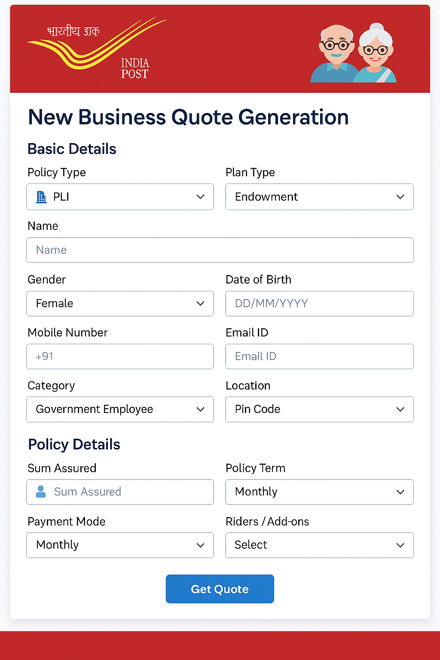

4.2 Quote Generation for Other Transactions
The system shall allow users to generate quotes for:
- Surrender: Calculate surrender value, integrate loan recovery, display net payable amount. Separate surrender calculation for CWL and EA Products.
- Revival: Include GST heads, handle instalment failures, implement grace period logic, show number of revivals available.
- Commutation: Implement logic for commutation quotes.
- Conversion: Correct premium calculation for age-band conversion (EA/45 → EA/55), resolve zero-premium issue, add disclaimer for premium requirement.
- Loan: Update eligibility logic per product rules, include disclaimer for forced surrender.
- Reduced Paid-Up: Calculate surrender value, show disclaimer that policy cannot be revived after RPU approval.
- Premium Paid Certificate: Provide downloadable certificate for policyholder.

Flow Chart for Generating Quote for Other Transactions:
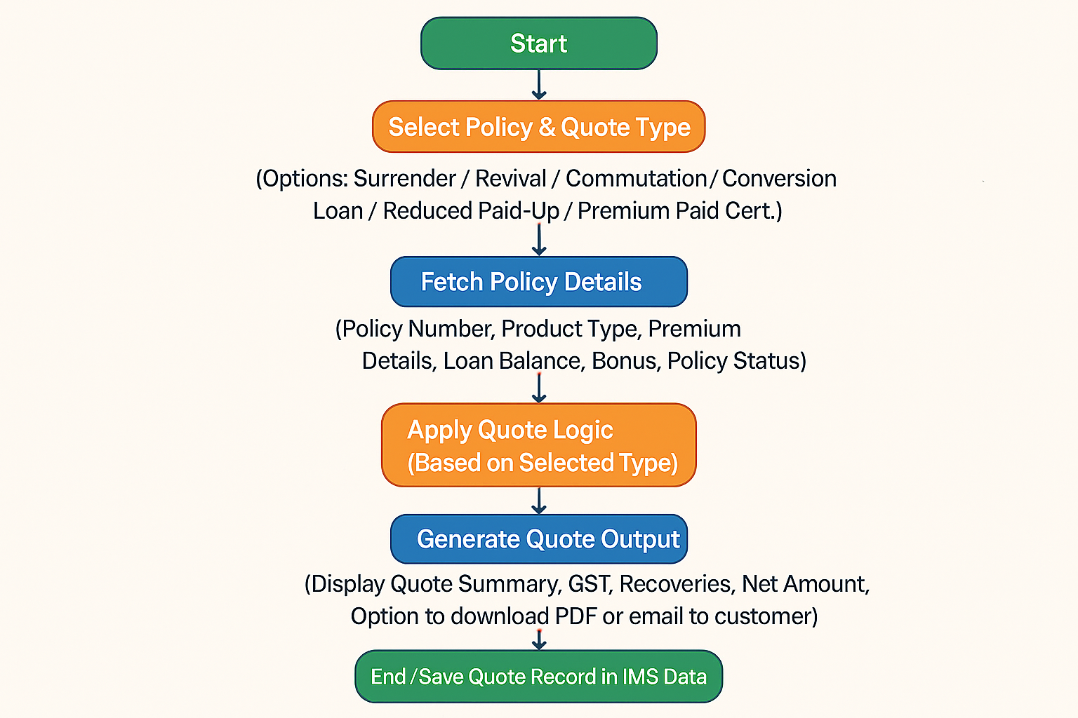

Wireframe for Quote Generation for Other Transactions Page: 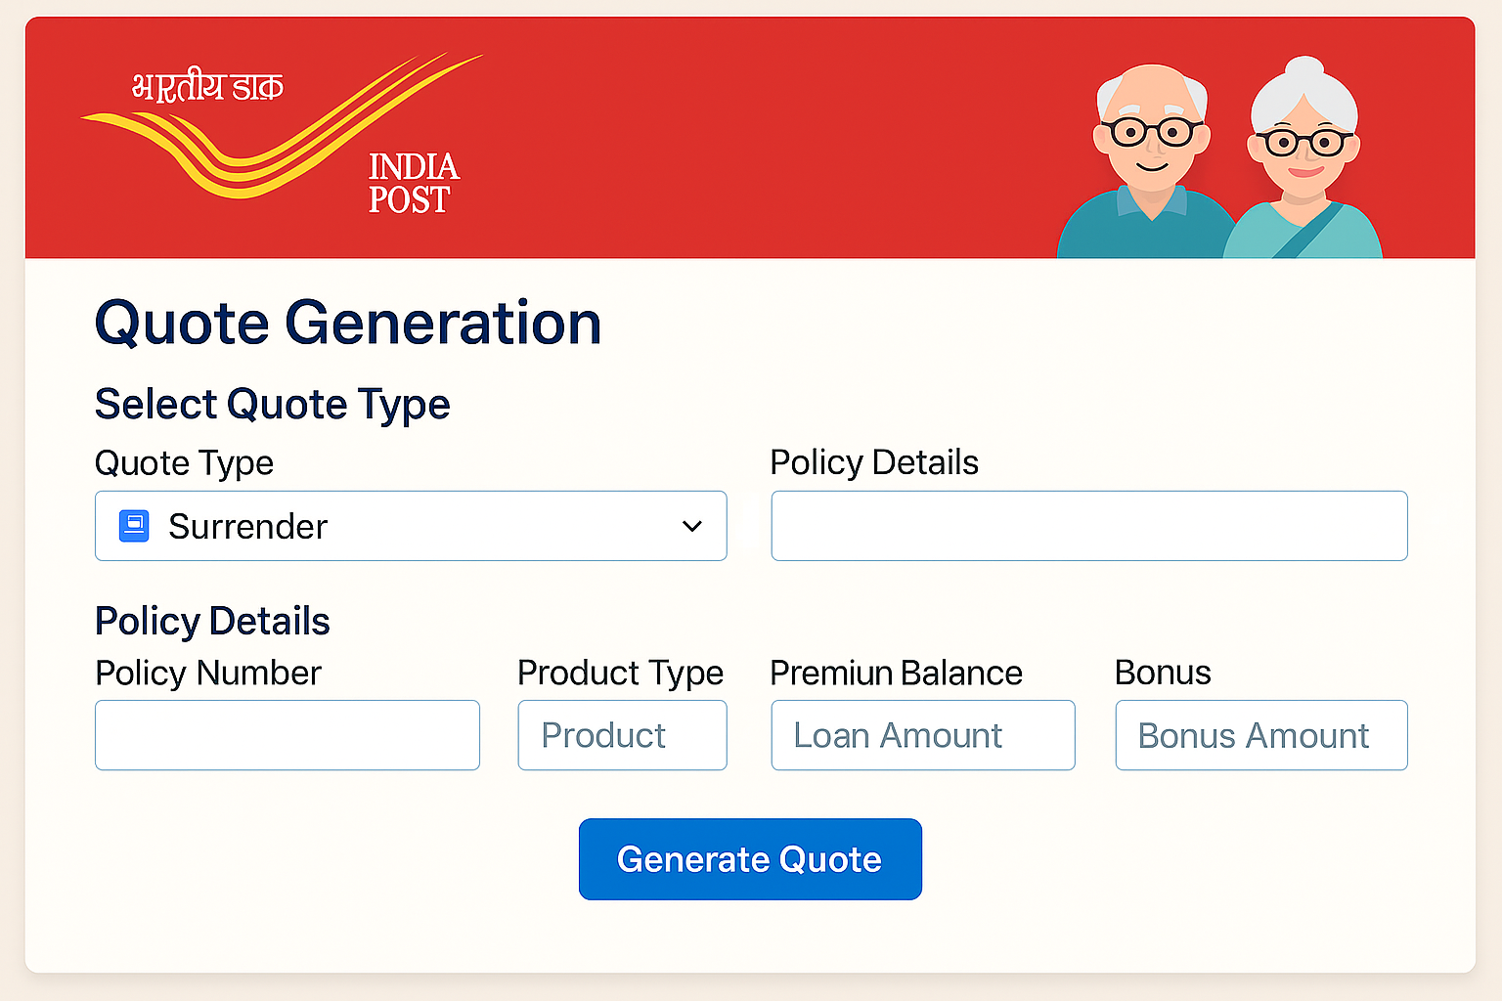

5. Attachments
The following documents can be referred.

